Title example for paper in this international conference
InitialFirstName Surname¹ and InitialFirstName Surname²

¹Affiliation, Address Affiliation (with country)
²Affiliation, Address Affiliation (with country)

E-mail: corresponding author
Abstract. All articles must contain an abstract. The abstract text should be formatted using 10 point Times or Times New Roman and indented 25 mm from the left margin. Leave 10 mm space after the abstract before you begin the main text of your article, starting on the same page as the abstract. The abstract should give readers concise information about the content of the article and indicate the main results obtained and conclusions drawn. The abstract is not part of the text and should be complete in itself; no table numbers, figure numbers, references or displayed mathematical expressions should be included. It should be suitable for direct inclusion in abstracting services and should not normally exceed 200 words in a single paragraph. Since contemporary information-retrieval systems rely heavily on the content of titles and abstracts to identify relevant articles in literature searches, great care should be taken in constructing both. This is an example. This is an example. This is an example. This is an example. This is an example. This is an example. This is an example.
- Introduction
The text of your paper should be formatted as follows: (1) 11 point Times or Times New Roman; (2) The text should be set to single line spacing; (3) Paragraphs should be justified; and (4) The first paragraph after a section or subsection heading should not be indented; subsequent paragraphs should be indented by 5 mm.

1.1. Subsection 1
Each figure should have a brief caption describing it and, if necessary, a key to interpret the various lines and symbols on the figure. You are free to use colour illustrations for the online version of Journal of Physics: Conference Series but any print version will only be printed in black and white unless special arrangements have been made with your conference organizer for colour printing. Please check with the conference organizer whether or not this is the case. If any print version will be black and white only, you should check your figure captions carefully and remove any reference to colour in the illustration and text. In addition, some colour figures will degrade or suffer loss of information when converted to black and white and this should be taken into account when preparing them.

1.1.1. Subsubsection. Individual figures should normally be centred but place two figures side-by-side if they will fit comfortably like this as it saves space. The following examples show how to format a number of different figure/caption combinations.

 | 
 | Figure 1. Figure with short caption (caption centred).
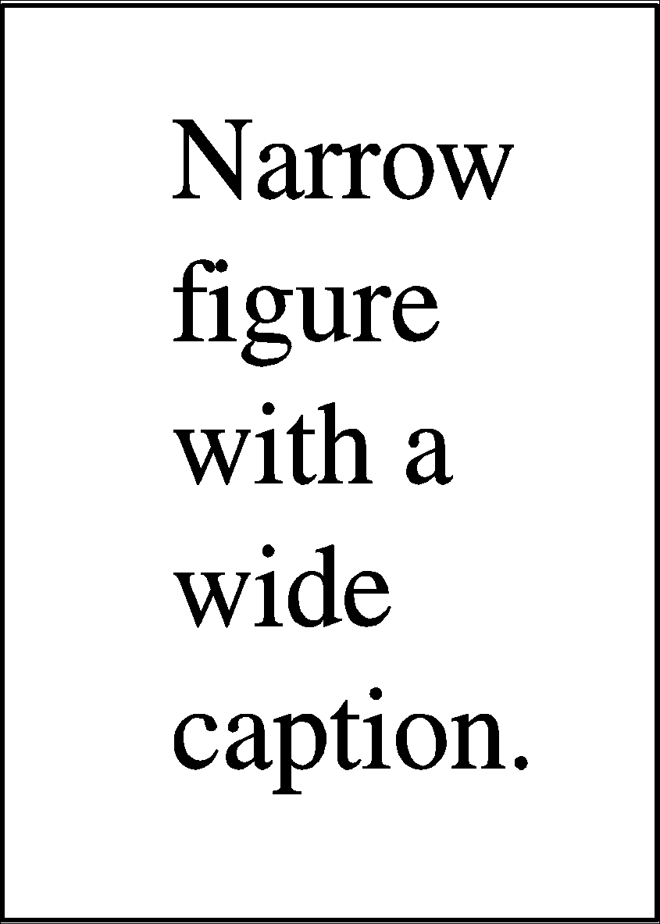 |  | Figure 2. This is a figure with a caption that is wider than the actual graphic. To save space you can put the caption to the right of the figure by placing the graphic and justified caption in a table with one row and two columns.


Figure 3. In this case simply justify the caption so that it is as the same width as the graphic.
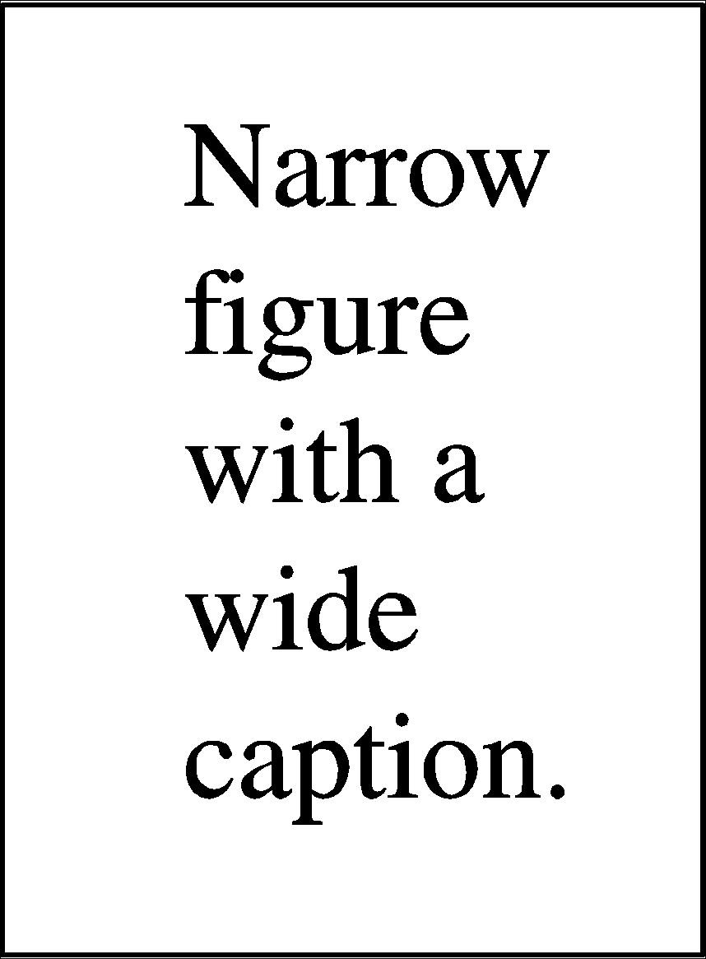
Figure 4. These two figures have been placed side-by-side to save space. Justify the caption. |  | Figure 5. These two figures have been placed side-by-side to save space. Justify the caption.

1.2. Subsection 2
The use of sections to divide the text of the paper is optional and left as a decision for the author. Where the author wishes to divide the paper into sections the formatting shown in table 1 should be used.
Table 1. Formatting sections, subsections and subsubsections.
 | Font | Spacing | Numbering
Section | 11 point Times bold | 1 line space before a section  No additional space after a section heading | 1, 2, 3, etc
Subsection | 11 point Times Italic | 1 line space before a subsection  No space after a subsubsection heading | 2.1, 2.2, 2.3, etc
Subsubsection | 11 point Times Italic | Subsubsections should end with a full stop (period) and run into the text of the paragraph | 2.3.1, 2.3.2, etc

- Topic1
Section on the topic can be more than one according to the needs of the author. The content of the topic section according to the author's needs. For the section "topic", the author gives the title according to the needs of the author and the number of topics according to the needs of the author. If there is only one topic, then the section number follows to be: 1. Introduction, 2.Topic (title according to author's need), 3. Conclusion, 4. References.
- Topic2
Section on the topic can be more than one according to the needs of the author. The content of the topic section according to the author's needs. This is an example. This is an example. This is an example. This is an example. This is an example. This is an example. This is an example. This is an example. This is an example. This is an example. This is an example. This is an example.
- Conclusion
This is an example. This is an example. This is an example. This is an example. Please make sure you read the author guidelines to clarify how the article is written. This template is just an example.

Acknowledgments
Authors wishing to acknowledge assistance or encouragement from colleagues, special work by technical staff or financial support from organizations should do so in an unnumbered Acknowledgments section immediately following the last numbered section of the paper.

- References
[1] Sze S M 1969 Physics of Semiconductor Devices (New York: Wiley–Interscience)
[2] Dorman L I 1975 Variations of Galactic Cosmic Rays (Moscow: Moscow State University Press) p 103
[3] Caplar R and Kulisic P 1973 Proc. Int. Conf. on Nuclear Physics (Munich) vol 1 (Amsterdam: North-Holland/American Elsevier) p 517
[4] Szytula A and Leciejewicz J 1989 Handbook on the Physics and Chemistry of Rare Earths vol 12, ed K A Gschneidner Jr and L Erwin (Amsterdam: Elsevier) p 133

